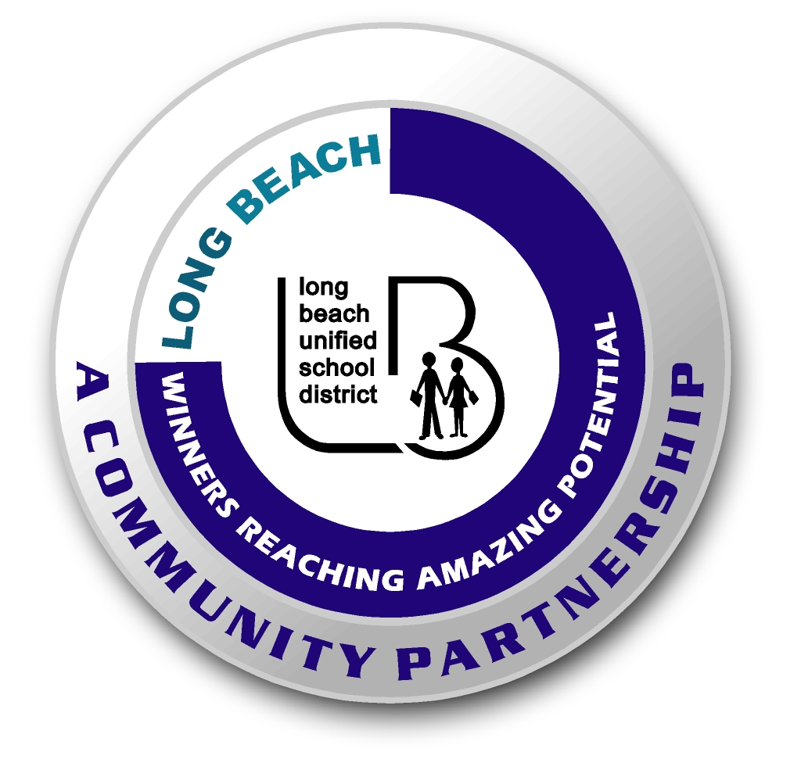
Long Beach WRAP

Lesson Title or Topic: Soaking Eggs

Program Leader: _____________________________ Date: __________

Grade Level: 1st School Site: __________________________

Materials Needed: (List)
- Raw egg
- Glass
- Vinegar
- Water for rinsing
- Class graph for predicting

Preparation Time: 10 min Lesson time: 20 minutes each day. The egg must sit for two days.

Content Standard(s):
Physical Science: Materials come in different forms (states), including solids, liquids, and gases. As a basis for understanding this concept: Students know the properties of substances can change when the substances are mixed, cooled, or heated.

Investigation and Experimentation: Students will draw pictures that portray some features of the experiment, record observations and data with pictures, numbers, or written statements, and record observations on a bar graph.

What will be learned from this activity? (Objective)
Students will learn that an acid can dissolve some solids but not others.

Steps of the lesson: (Scientific Method of Investigation)
Information: Vinegar, which is an acid, will cause the calcium in the egg shell to dissolve. The egg will appear to be rubbery in texture.

Introduction: (Questions/Hypothesis):
What will happen to a raw egg when it is soaked in vinegar for two days?

Instruction:
1. Show students materials to be used in the experiment and state the problem.
2. Explain vocabulary for the different hypotheses if necessary.
3. Have students choose a hypothesis. Have students complete this sentence frame: The raw egg will _______________________. Possible hypotheses: become rubbery, harden on the outside, have its yolk disappear, or change color.
4. Chart all student predictions on a class graph.
5. Ask volunteers to explain the reasons for their predictions.
6. Conduct the experiment.

Activity:
- Have students describe the feel of the raw egg.
- Place the raw egg in a glass.
- Fill the glass with enough vinegar to cover the egg.
- Let it sit for two days.
- Observe what happens to the egg over the two days.
- After second day, rinse egg and have the students feel the texture.
- Observe what happened.

Closure: (Conclusions/Results)
- What were the results? Discuss the results.
- Have students write: The egg ____________________. Then they can draw a picture of the experiment.

