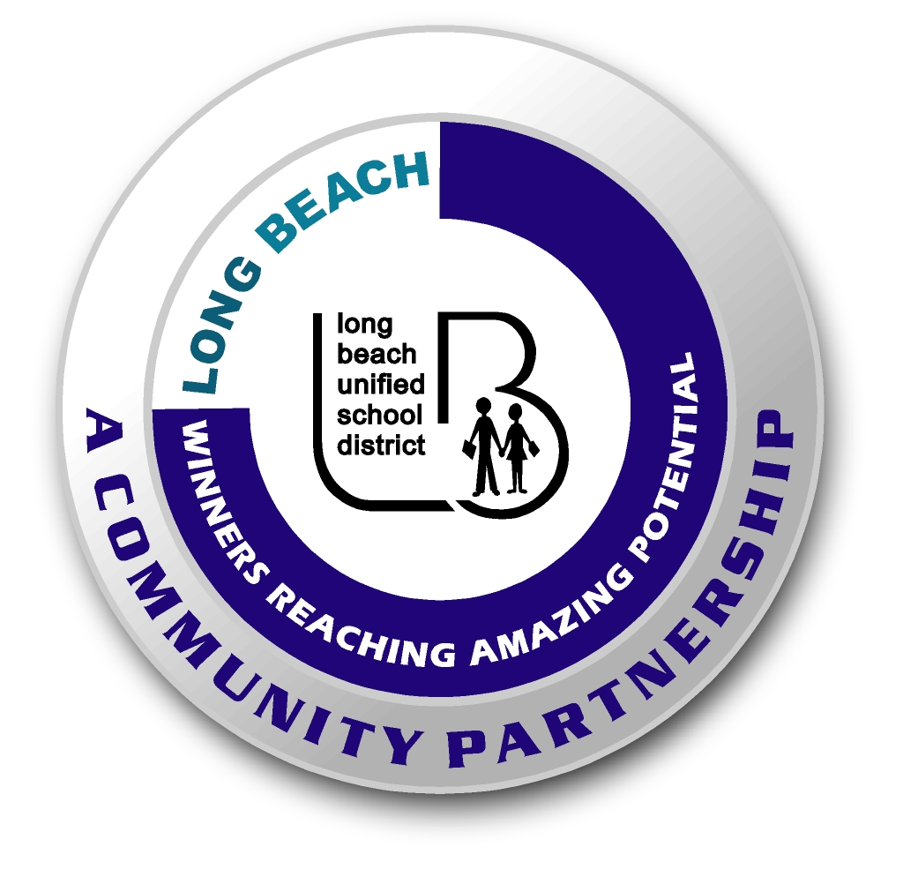
WRAP Program Office

Service Learning Resources

SLICE | www.servicelearning.org/slice
Learn and Serve America | www.learnandserve.org
Roots & Shoots | www.rootsandshoots.org
Youth Service America | www.ysa.org

