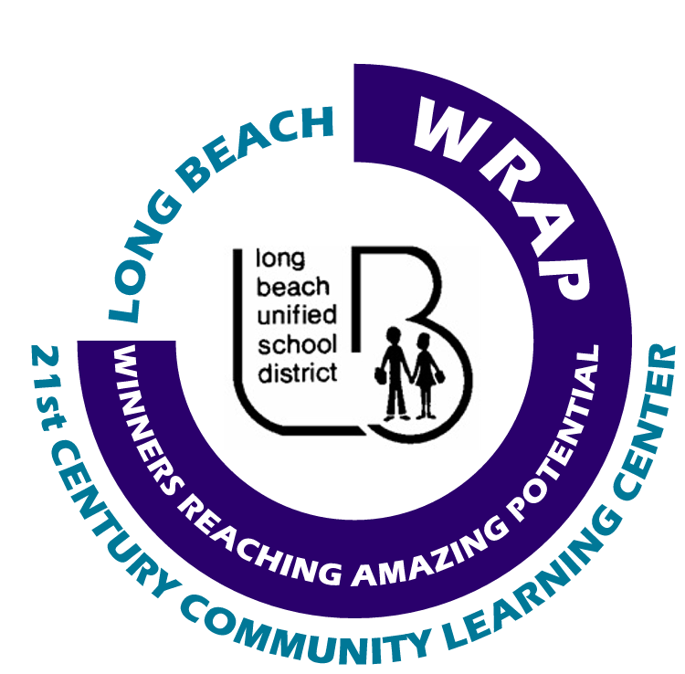Long Beach WRAP
“Winners Reaching Amazing Potential”

After-School Programs

Homework Assistance
Effective Date: 07.01.06 | Policy # 001
Policy: Each Partner Agency must adhere to the Homework Assistance Guidelines as listed below.
Purpose: To provide students with homework assistance in an environment that facilitates productivity and success.

Guidelines:
- The homework assistance hour must be held in a classroom. All homework assistance hour supplies will be provided by the after-school program provider. Teacher’s items are not to be used unless given written permission by the teacher.
A Classroom/Facility Checklist must be filled out once a week when using classrooms.
- Program Leader’s are to be actively assisting students with their work at all times. Program Leader’s must be circulating around the room, monitoring student’s progress.
- No personal work is to be done while on duty. Anyone found doing personal work (reading, studying, etc) will be written up.
- Students who do not have assigned homework or who finish their homework before the conclusion of the homework assistance hour must be provided with academic based learning activities. An academic based learning activity is defined as any activity which has a clear objective, is hands on and engaging and produces measurable outcomes.
- As per the signed Parent Agreement upon student enrollment, the homework hour is ONE HOUR in length. If a student is continually unable to complete his/her homework, then their parent and teacher will be notified.
- A homework log must be completed on a daily basis.
- An Homework Communication Sheet should be completed on an as needed basis (optional).

Source: LB WRAP Policies and Procedures Committee

Template: Homework log and key
Homework Communication Sheet (optional)

