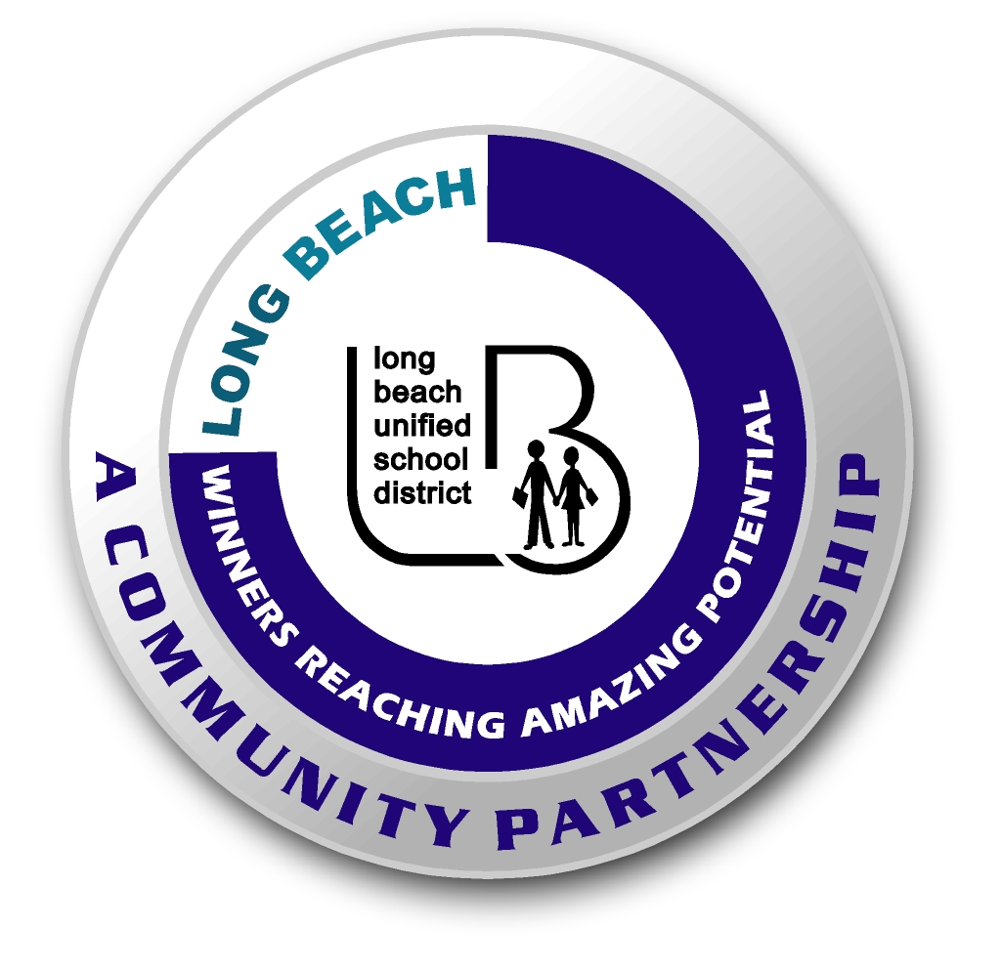
Long Beach WRAP

Lesson Title or Topic: Leaking Bottle

Program Leader: _____________________________ Date: __________

Grade Level: 1st School Site: __________________________

Materials Needed: (List)
- Plastic bottle
- Water
- Push pin
- Class graph for predicting

Preparation Time: 10 min Lesson time: 30 min

Content Standard(s):
Physical Science: Materials come in different forms (states), including solids, liquids, and gases. As a basis for understanding this concept: Students know solids, liquids, and gasses have different properties.

Investigation and Experimentation: Students will draw pictures that portray some features of the experiment, record observations and data with pictures, numbers, or written statements, and record observations on a bar graph.

What will be learned from this activity? (Objective)
Students will learn that air pressure exerts a greater force than water pressure when the water is in a sealed container.

Steps of the lesson: (Scientific Method of Investigation)
Information: Air presses from outside the bottle and water presses from inside the bottle. The air pressure on the outside is stronger than the water pressure inside. Thus, the water is kept from pouring out the small hole created when you pull the push pin out of the side of the bottle.

Introduction: (Questions/Hypothesis):
What will happen to the water in a plastic bottle when it is punctured with a push pin?

Instruction:
1. Show students materials to be used in the experiment and state the problem.
2. Have students choose a hypothesis. Have students complete this sentence frame: The water will ___________________. Possible hypotheses: stay inside, squirt out, pop the lid off, make a hissing sound.
3. Chart all student predictions on a class graph.
4. Ask volunteers to explain the reasons for their predictions.
5. Conduct the experiment.

Activity: (Procedure)
- Poke a push pin into a plastic bottle. Leave it in the bottle.
- Fill the plastic bottle with water.
- Screw the cap on tight.
- Remove the push pin.
- Observe what happens to the water.

Closure: (Conclusions/Results)
- What were the results? Discuss the results.
- Have students write: The longest water ___________________. Then they can draw a picture of the experiment.

