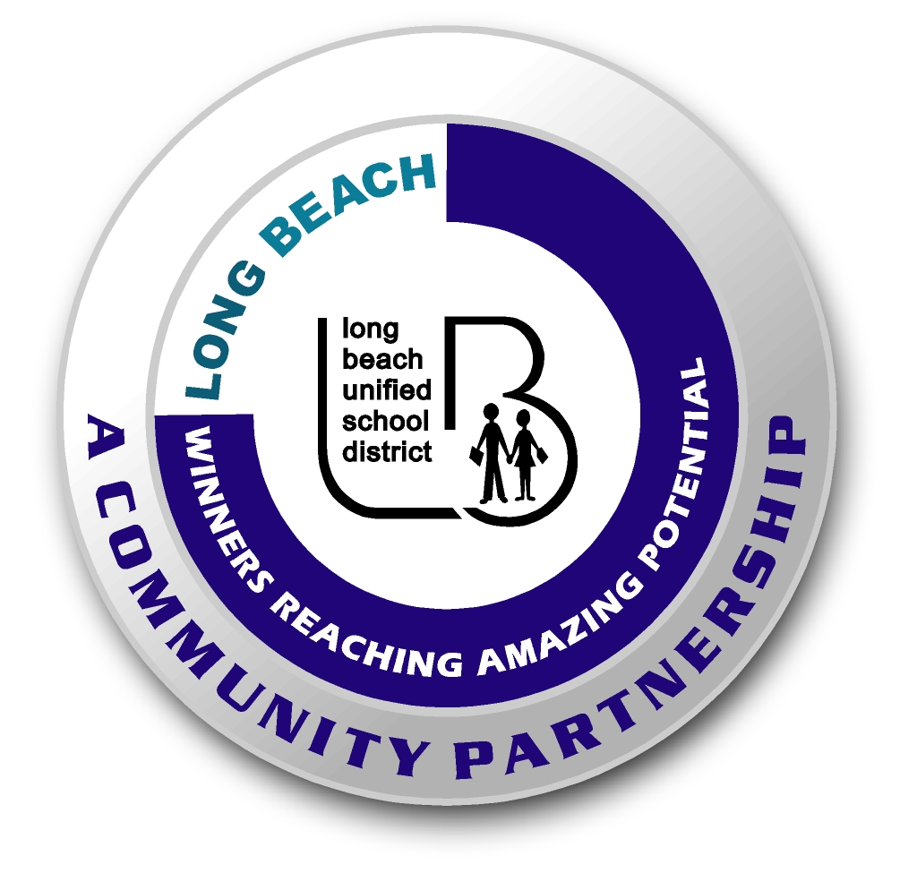
Long Beach WRAP

Lesson Title or Topic: Classification

Program Leader: _____________________________ Date: __________

Grade Level: K-2 School Site: __________________________
Created by: Hank Waddles

Materials Needed: (List)
- One sheet of butcher paper
- Glue
- A few examples of three materials: vegetable, mineral, and man-made

Preparation Time: 5 min Lesson time: 30 min

Content Standard(s) Kindergarten: Investigation and Experimentation 4 A and D

What will be learned from this activity? (Objective)
- Students will classify vegetable, mineral, and man-made objects by sorting found items onto a chart.

Steps of the lesson: (Scientific Method of Investigation)

Introduction: (Questions/Hypothesis):
- The world around us is filled with many different types of things, and they are usually divided into three categories: animal, vegetable, and mineral.
- Today we’re going to learn the different characteristics of these different categories.

Instruction:
- First, since we can’t bring animals in here, we’re going to talk about vegetables, minerals, and man-made objects.
- Here are some examples: (Teacher should show examples, which could include an orange, a rock, and a walkie-talkie.)
- Teacher should point out the differences between the three categories: vegetable material is, or was once, alive; minerals were never alive; and man-made objects do not exist in nature.

Activity: (Procedure)
- Divide students into groups of six and prepare for the Science Scavenger Hunt
- Release students to the recreation area with instructions that each team member must look for these items.
- When the teams return, have each student classify his or her object onto the piece of butcher paper.

Closure: (Conclusions/Results)
- Okay, let’s look at the items in the vegetable column. What do they have in common?
- What about the mineral and man-made columns. What do we see there?

