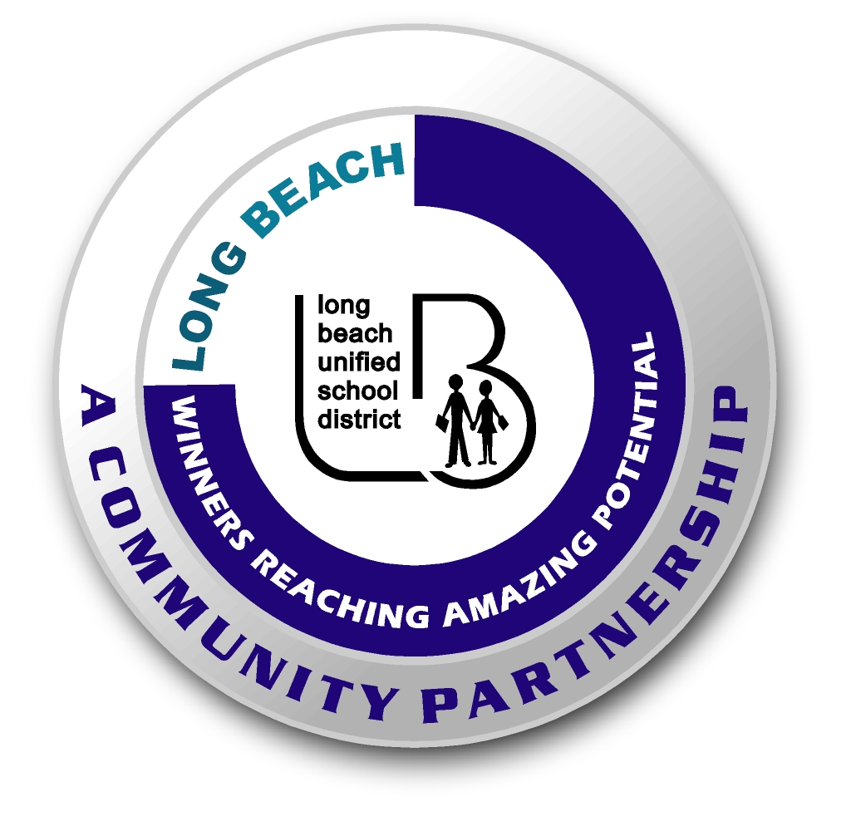
Long Beach WRAP

Lesson Title or Topic: “Spinning Blimps”
*This lesson and materials can be found in the science bins on site! They have visuals and items bagged and ready to use! Please see the: Science Explorer for Groups Kit, in bin #3: Flying, Static, & Color
Program Leader: _____________________________ Date: __________

Grade Level: 3rd School Site: __________________________

Materials Needed: (List)
- paper 4. ruler
- pencil 5. crayons
- scissors

Preparation Time: 5 min Lesson time: 30 min

Content Standard(s)
Investigation and Experimentation: predict outcome of a simple investigation and compare results.

What will be learned from this activity? (Objective)
Students will experiment with spinning blimps and compare outcomes.

Steps of the lesson:

Introduction: We are going to be learning about rings, wings, and other flying things.

Instruction: “Today we are going to create a spinning blimp and do several experiments with it. Model the step by step procedure and proper use of the materials for students.

Activity: (Procedure)
- Cut a strip of paper about 6 to 8 inches long and ½ inch wide.
- Cut halfway across the strip about ½ inch from one end. Turn the strip around and do the same thing on the other end. See guide in bin for visual!
- Slip the slot at one end into the slot at the other end. You’ll make something that looks like a little fish.
- Fold the bottom up and put a paper clip on it.
- Now you have a blimp that spins through the air. It’s really simple to make more blimps and experiment with changes in the design. Challenge groups to come up with a blimp that can stay up for a longer amount of time or spins faster.
- It is best if you make just one change at a time. Here are some things they can try: Make the paper strip longer or shorter. Make the strip wider or narrower. Make the tails longer or shorter. Cut the ends of the tails so they are pointed. Use different kinds of paper.
- You can allow students to color their paper strip before you fold them into a blimp. That makes the color patterns spin in the air.

Closure: (Conclusions/Results)
- What were the results?
- Have students make conclusions, ask what caused the spinning blimps to spin faster or slower?
- Read the paragraph titled “Learning to experiment” located on the pamphlet in the bin. This baggie contains a few tips.

