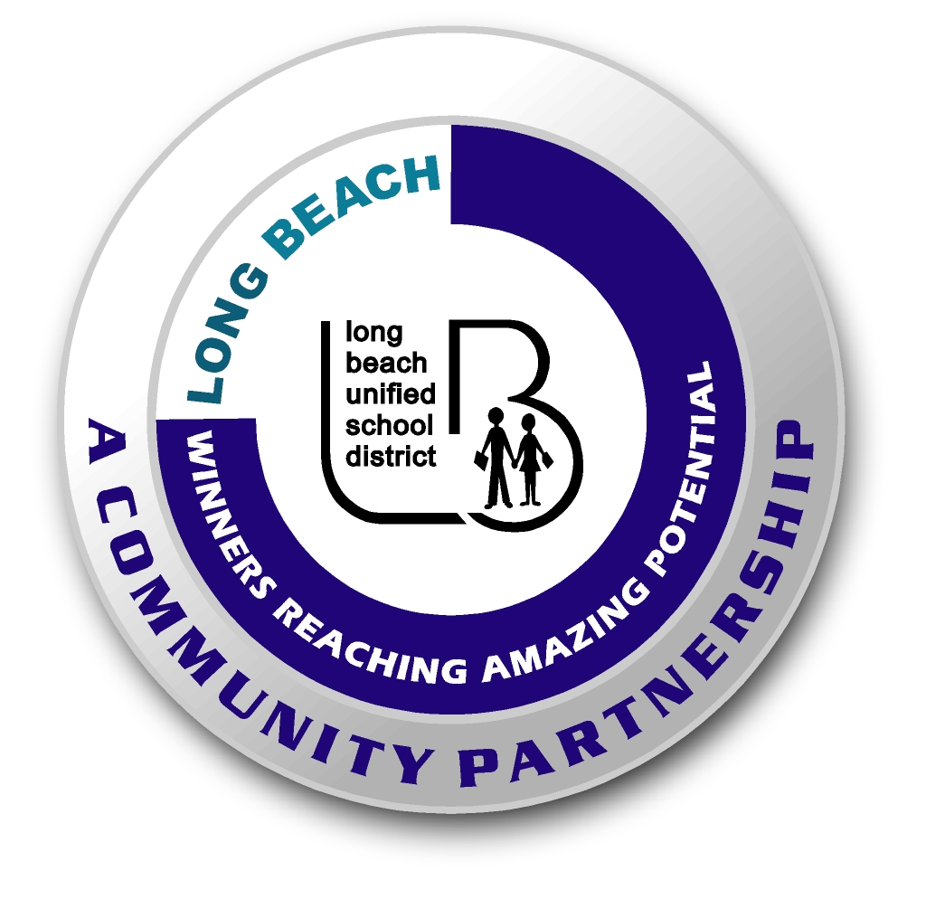
Long Beach WRAP

Lesson Title or Topic: Objects in Motion

Program Leader: _____________________________ Date: __________

Grade Level: K-2 School Site: __________________________
Created by: Hank Waddles

Materials Needed: (List)
- One basketball
- One board to be used as a ramp
- Chalk

Preparation Time: As much time as it takes to gather the supplies.
Lesson time: 20 minutes, best done outside on the blacktop.

Content Standard(s) 2nd Grade: Physical Sciences 1D: Students know tools and machines are used to apply pushes and pulls (forces) to make things move.

What will be learned from this activity? (Objective)
- Students will demonstrate their understanding of how forces make things move by rolling a basketball down a ramp and measuring the distance the ball rolls.

Steps of the lesson: (Scientific Method of Investigation)

Introduction: (Questions/Hypothesis):
- Take a look at this basketball resting on the ground in front of me. Unless something pushes or pulls on it, it will sit here forever. What types of things might make it move? (Be sure that students come up with a variety of responses: someone could throw it, kick it, dribble it, or the wind could blow it, etc.)
- Correct! All those things are called forces, and it takes force to move an object – like this… (demonstrate by lightly pushing the ball towards a student).

Instruction:
- Today we’re going to experiment with forces, but we aren’t going to dribble, pass, throw, kick, shoot, or even push the basketballs. We’re going to let gravity apply the force.
- Demonstrate that you can use one of the boards as a ramp by raising it to a particular height and launching the basketball by simply letting it roll down the ramp.

Activity: (Procedure)
- Divide students into groups of four.
- Explain that they will take turns launching their basketballs, and that they can raise the ramp to any angle they choose.
- After each group rolls its basketball, use the chalk to mark the distance the ball travels.
- After each group has had three rolls, declare a winning group.

Closure: (Conclusions/Results)
- Okay, what does the ramp have to do with this activity? (Students should realize that the ramp is a tool that applies a push (or force) to the basketball).
- Why do you think it wasn’t best to just raise the ramp up as high as you could?

