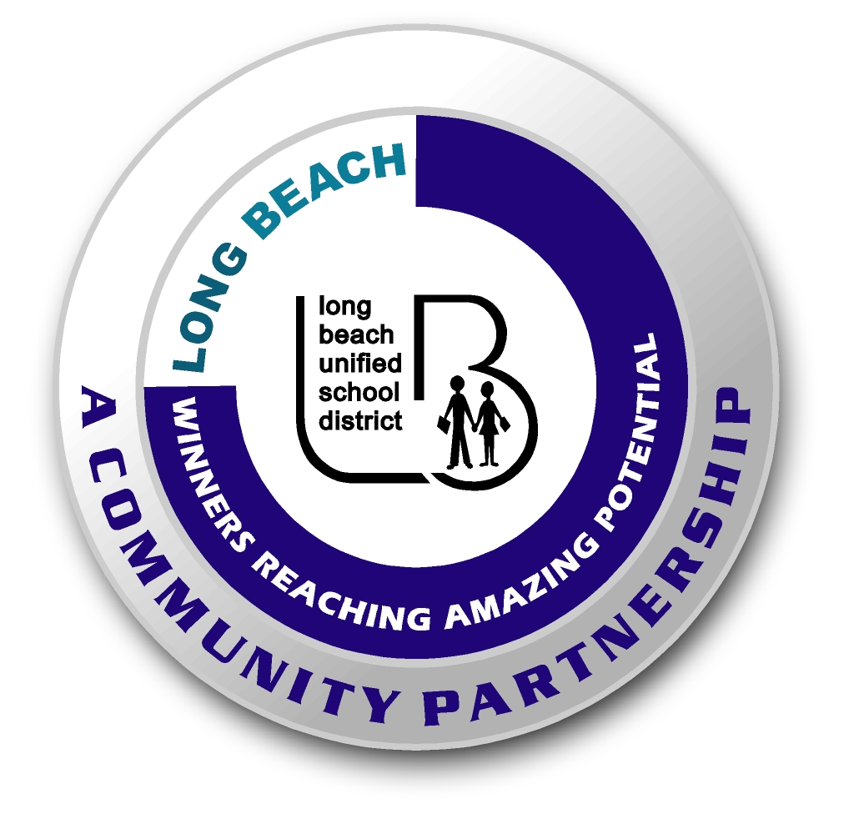
Long Beach WRAP

Lesson Title or Topic: Sharks and Sea Lions (Physical Activity)

Program Leader: _____________________________ Date: __________

Grade Level: 6-8^{tth} School Site: __________________________

Materials Needed: (List)
- Wrapped individual pieces of candy (starbursts, tootsie rolls etc.)
- Playground area: Use cones to mark off the 2 areas: shark zone and sea lion safe zone
Preparation Time: 10 min Lesson time: 30 min

Content Standard(s) Ecology 5b

What will be learned from this activity? (Objective)
- Predator-prey relationships
- Food Chains effect on predator-prey relationships

Steps of the lesson: (Scientific Method of Investigation)

Introduction: (Questions/Hypothesis):
- What is a Predator? What is Prey?
- Where can a sea lion live that a shark cannot? What might happen when the sea lions food supply lessens? What could happen to the sharks when there are no more sea lions?
- What is a food web?

Instruction: (Discuss Topics in the Introduction)

Activity: (Procedure) (The Games Rules)
- Spread out the sea lion’s food (the candy) in the shark zone and assign points if you would like to add some competition to the game.
- Sharks are limited to an area of the playground. Sea lions have two safe zones on opposite sides of the shark zone.
- The sea lions have to run through, grab some food, or not, without being eaten (tagged) by the sharks. Sea lions have three chances to go through the shark zone to grab some food, if they do not they are out of the game. Ask the students why they think this is a rule?

Closure: (Conclusions/Results) during the game have the students make observations about what is taking place.
- Why are the faster sea lions getting through?
- What happens when the sea lions food supply goes down?
- Why are some sea lions caught before others?
- What will happen to the sharks when all of the sea lions are gone?

