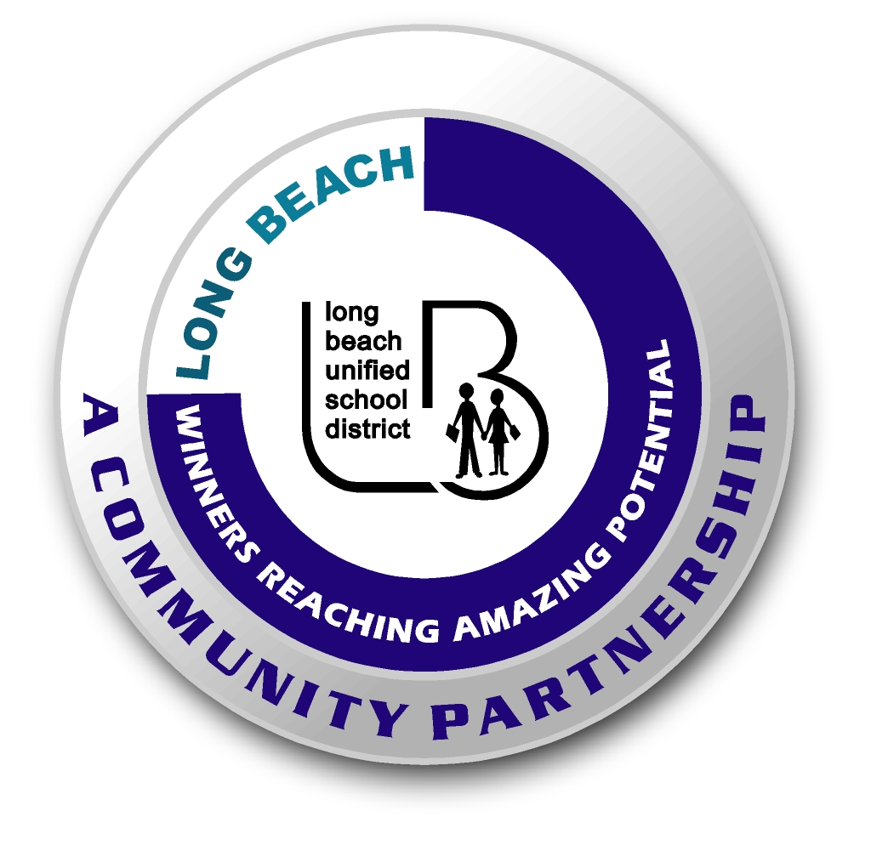
Long Beach WRAP

Lesson Title or Topic: Sinking Paper

Program Leader: _____________________________ Date: __________

Grade Level: 1st School Site: __________________________

Materials Needed: (List)
- Two glasses
- Dishwashing soap
- Cutouts for dipping into water (man, shape, etc.)
- Water
- Class graph for predicting

Preparation Time: 10 min Lesson time: 30 min

Content Standard(s):
Physical Science: Materials come in different forms (states), including solids, liquids, and gases. As a basis for understanding this concept: Students know the properties of substances can change when the substances are mixed, cooled, or heated.

Investigation and Experimentation: Students will draw pictures that portray some features of the experiment, record observations and data with pictures, numbers, or written statements, and record observations on a bar graph.

What will be learned from this activity? (Objective)
Students will learn that detergent reduces the surface tension of water.

Steps of the lesson: (Scientific Method of Investigation)
Information: Detergent added to water reduces the surface tension. The molecules tend to break apart making the water seem “wetter”. In this experiment both paper cutouts begin to sink, but the one in the soapy water sinks faster because the “wetter” water soaks into the paper fibers more quickly.

Introduction: (Questions/Hypothesis):
What will happen to a paper cutout when it is put into soapy water, compared to one put in plain water?

Instruction:
1. Show students materials to be used in the experiment and state the problem.
2. Have students choose a hypothesis. Possible hypotheses for what will happen to the cutout put in the soapy water: a. float, b. sinks, c. sinks slower, d. sinks at the same time. These should be the headings on the graph.
3. Chart all student predictions on a class graph.
4. Ask volunteers to explain the reasons for their predictions.
5. Conduct the experiment.

Activity: (Procedure)
- Fill two glasses with tap water.
- Add soap to one of them.
- Hold a paper cutout over each glass.
- Put them into the water.
- Observe what happens.

Closure: (Conclusions/Results)
- What were the results?
- Have students write: The paper in the soapy water ___________________. Then they can draw a picture of the experiment.

