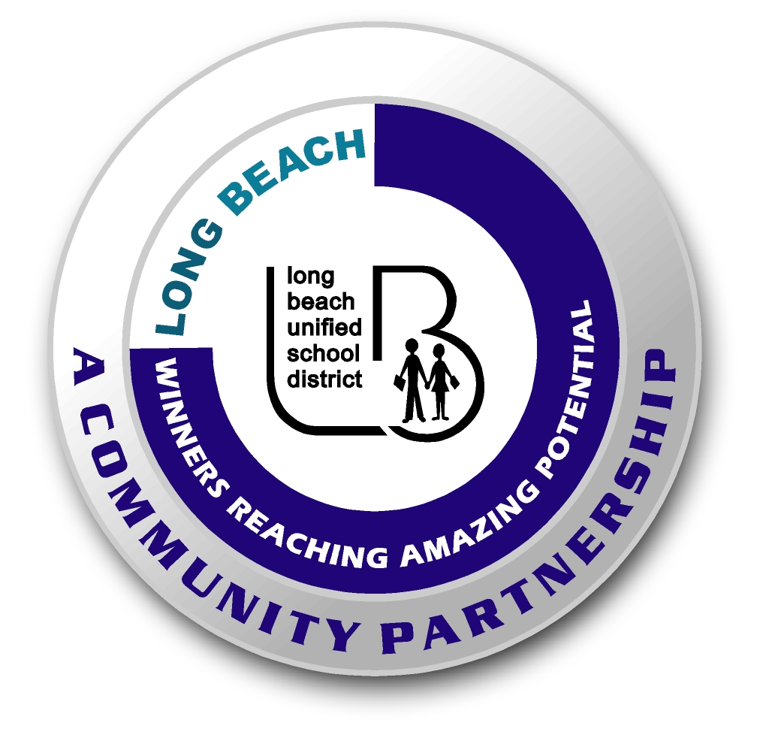
Long Beach WRAP

Lesson Title or Topic:

“What Else Can I Do With Static Electricity?”
*This lesson and materials can be found in the science bins on site! They have visuals and items bagged and ready to use! Please see the: Science Explorer for Groups Kit, in bin #3: Flying, Static, & Color
Program Leader: _____________________________ Date: __________

Grade Level: 3rd – 5th School Site: __________________________

Materials Needed: (List)
- balloons
- container of small stuff
- aluminum pie pan

Preparation Time: 5 min Lesson time: 30 min

Content Standard(s)
Physical Sciences: Energy can be carried from one place to another.
Investigation and Experimentation: predict the outcome of an investigation and compare results.

What will be learned from this activity? (Objective)
Students will conduct several experiments with static electricity and develop conclusions as a result.

Steps of the lesson:

Introduction: We are going to be learning about static electricity by trying several tricks and experiments.

Instruction: “Today we are going to use static electricity to show how electrons and protons are both positively charged. For example, when you rub a plastic to your hair, you add electrons to the plastic.”

Activity: (Procedure)
- “Wiggle your Beans”: using static electricity, you can make tiny things like rice, beans, paper, etc. dance or jump. Have students find 5 other things that will move when they rub a balloon on their head then place it next to the item.
- “Rub this on your Head”: Try other plastic things like a plastic comb, a margarine tub, etc. Have students find three more things that will hold the static charge.
- “Give your head a Rest”: Start with a balloon and try to find other things you can rub it on to create static electricity. You can use a wool sweater, dog’s fur, a sock, or t-shirt. Did any of this work?
- “Bend Water”: Turn on the faucet in the kitchen. Don’t run the water hard, but more than a little trickle. Now rub a balloon on your head and hold the balloon near the water. The stream of water will bend toward the balloon.
- Read the paragraph titled “Dramatic Static” located on the pamphlet in the bin. This baggie contains a few tips and interesting facts.
Closure: (Conclusions/Results)
- What were the results?
- Have students make conclusions, ask them to share with their neighbor what they learned about static electricity today.

